**PRÁCA S ATLASOM ☺**

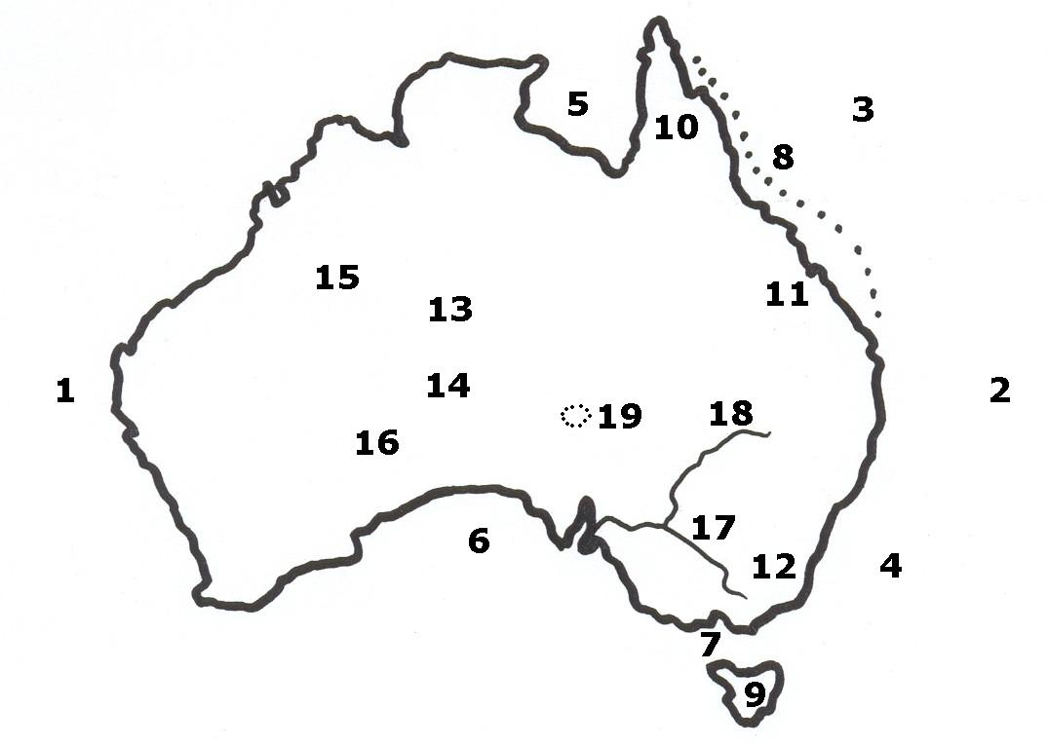

1. ................................................... oceán 10. ................................................... polostrov

2. ................................................... oceán 11. ................................................... vrchy

3. ................................................... more 12. ................................................... alpy

4. ................................................... more 13. ................................................... vrchy

5. ................................................... záliv 14. ................................................... vrchy

6. ................................................... záliv 15. ................................................... púšť

7. ................................................... prieliv 16. ................................................... púšť

8. ................................................... bariéra 17. ................................................... rieka

9. ................................................... 18. ................................................... rieka

19. ................................................... jazero